

Machine Learning Techniques for Game of Thrones

Machine Learning

Jiwei Li

March 2019

Machine Learning Techniques for Game of Thrones Analysis Write-Up

Problem

Knowing who is going to be alive in “Game Of Thrones” throughout the chapters and different books is something really difficult to predict, and same or even more difficult, is to give recommendation to those who are still alive or to the ones that are going to be part of this universe. That is our mission in this report, to give insight on how to remain alive.

As a difference of many other stories, books, or TV shows, here anyone can die, even the popular characters. In the current stage there are 1451 characters alive and 493 has gone (GOT Data provided in the analysis, 2019).

Moreover, take your time and read carefully the following lines with the recommendation of what you should do to remain stand.

Actionable Key Insights

Because our spirit is to, first, give some insights about what to expect if you are or will be part of the World GOT.

Here is a list of the main insights:

- Related to the appearance in the books: in our analysis we can see that the characters that appears in the book N4 have more chances to be alive (positive correlated).

- Age: here the main thing to know, is that the older the worse for being alive, age has a negative correlation. Furthermore, people between 30 and 40 are more popular and this something not good if you want to be alive.

2

- Popularity: if you are a character too popular you have more chances to be killed/died, this is linked to previous bullet.

- Dead Relations: is also important highlight that the more Dead Relations you have, the bigger the chances of you been dead.
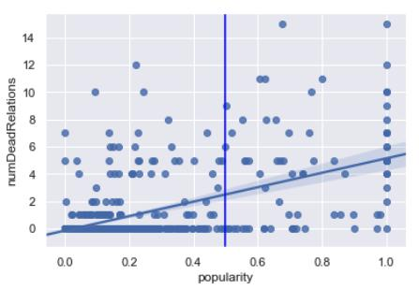

Predictions Analysis.

Thanks to this analysis we were able to create several models and we achieve to a champion (Random Forest) to predict if a character is alive or not, important for the ones still alive.:

- Key components of the model to predict: Age, Appearance in Book 4, Popularity, Type of Culture (less important), Appearance in Different Books, Dead Relatives. This is the most relevant information to gather in order to help you survive and give more personalized advice.

- Accuracy and AUC: we can predict with an accuracy of 94% (test score 0.943) and an Area Under the Curve of 98.2 % (0.982) with a model no too overfit (training score 0.950). This is our champion model: Random Model (with Randomized Search Tuned Parameters).

- Is also important to highlight, that from the remaining error, we have more errors in predicting people that could die but actually they lived, is always better to prevent than to regret!
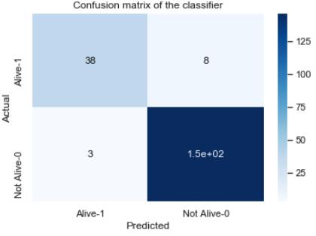

We can give quality advice to all of the characters still alive or future members if they give to us the data from the point N1 (Key Components of the Model), and we can give advices relating this with the section of Actionable Key Insights.

3

Final Conclusions

Be careful with popularity, you don’t want to be too popular and if you are older than 40 you need to be aware, is a risk age to be living inside of GOT. Also try to maintain safe your relatives, because those who lost their close people where prominent to die. And also important, try to remain alive from one book to other, this will give more chances in the long run to be alive!

Good Luck! Now with our help you can be the Captain of your own destiny!

4

References:

Game Of Thrones Wikipedia. Retrieved March 26, 2019, from https://gameofthrones.fandom.com/wiki/Game_of_Thrones_Wiki

Game Of Thrones, Wikipedia, Retrieved March 26, 2019, from https://en.wikipedia.org/wiki/Game_of_Thrones

Game Of Thrones, A Wiki Of Ice and Fire, Retrieved March 26, 2019, from https://awoiaf.westeros.org/index.php/Game_of_Thrones

5

